CSIT314 Software Development Methodologies - Group Project

Sprint 2 - US9: View user account
Interior Design Platform - User Admin
All diagrams were drawn in draw.io. Open "US9 View user account.drawio" in this folder to edit them - each diagram is its own page in that file. The exported images are in the "diagrams" folder.

Assumptions
- The system is the Interior Design Platform from the project specification. Sprint 2 covers the User Admin's search user profiles story (US7) and managing user accounts (US8 - US12).
- A user account is one person's login. It has a username, password, full name, email, phone, the user profile (group) it belongs to, a status (Active or Suspended) and the date it was created. Every account belongs to exactly one user profile and gets that profile's permissions.
- We follow B-C-E: the actor only talks to the boundary (page), the boundary only talks to the controller, and the controller works with the entity classes. There is one controller per use case.
- Simple input checks (empty fields) are done in the boundary. Business rules (e.g. unique usernames, active profile) are done in the controller. Entity classes read and write the database.
- The User Admin opens an account from the accounts list or the search results (UC12), so the userId is already known.
- The details page shows the username, full name, email, phone, the user profile (group) name, the status and the created date. The password is never shown, not even the hash.
- Suspended accounts can still be viewed. Viewing doesn't change any data.

1. User story
Story ID | US9
User story | As a user admin, I want to view a user account so that I can check the user's details, group, and account status.
Actor | User Admin
Priority | High
Story points (estimate) | 2
Acceptance criteria | 1. Given I click "View" on an account, then I see its username, full name, email, phone, user profile, status and created date.  2. The password is never shown.  3. Suspended accounts can be viewed too, with status "Suspended".  4. Given the account doesn't exist (e.g. a wrong link), then I see "Account not found".  5. From the details page I can go to Update (US10) or Suspend (US11).
Tasks | T9.1 Write the use case description and draw the use case diagram  T9.2 Draw the B-C-E class diagram and the sequence diagram  T9.3 Draw the wireframes for the account details page and the "not found" message  T9.4 Write the unit tests first (TDD) for UserAccount.getUserAccount() and ViewUserAccountController  T9.5 Code UserAccount.getUserAccount()  T9.6 Code ViewUserAccountController (gets the account and its profile)  T9.7 Code ViewUserAccountPage and its template  T9.8 Add the Update and Suspend buttons that link to US10 and US11  T9.9 Run the test cases, fix bugs and push to the repo so the CI pipeline runs the unit tests

2. Use case diagram
The user story becomes one use case, UC9 View user account. The User Admin is the only actor.
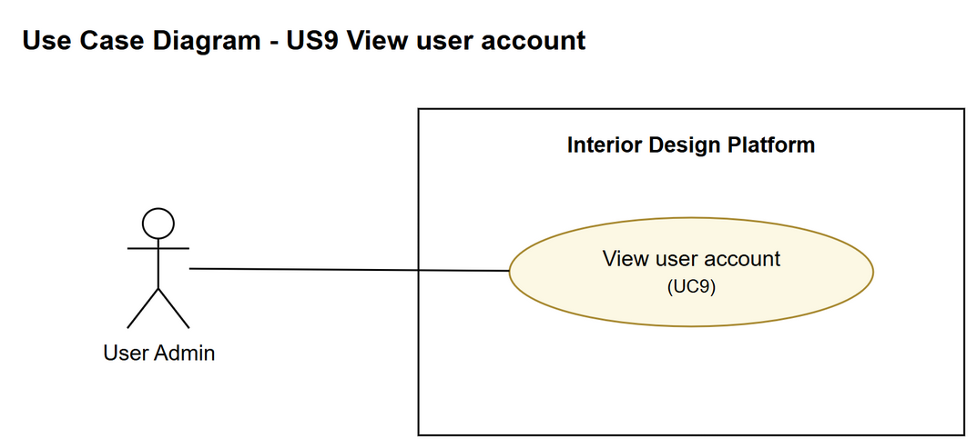
Figure 1: Use case diagram for US9 View user account

3. Use case description
Use case | UC9 View user account
Actor | User Admin
Brief description | The User Admin opens one user account to check the user's details, group and status.
User story | US9: As a user admin, I want to view a user account so that I can check the user's details, group, and account status.
Preconditions | The User Admin is logged in (UC1).  The User Admin is on the accounts list or the search results (UC12).
Trigger | The User Admin clicks "View" on a user account.
Basic flow | 1. The User Admin clicks "View" on a user account.  2. The system gets the account.  3. The system gets the user profile the account belongs to.  4. The system shows the account's details, the profile name, the status and the created date.
Alternative flows | 2a. The account doesn't exist: the system shows "Account not found".
Postconditions | Nothing in the system is changed.

4. Wireframes
The wireframes were drawn in draw.io. They are low-fidelity: they show the layout and the flow, not the final colours. The orange numbers match the notes under each screen.

4a - User account details
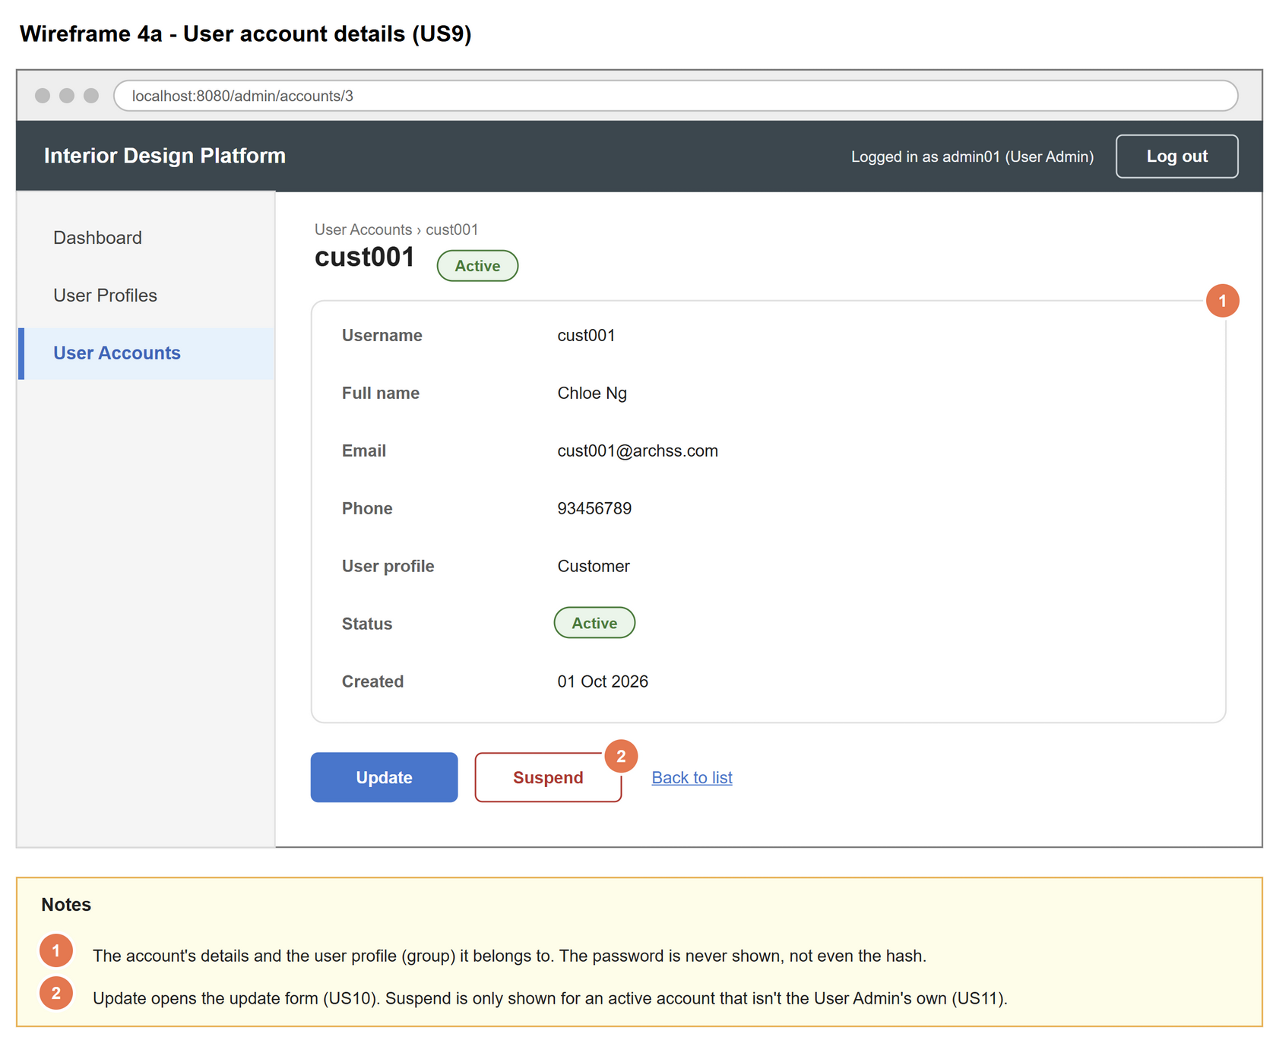
Figure 2: Wireframe 4a - User account details (US9)

4b - Account not found
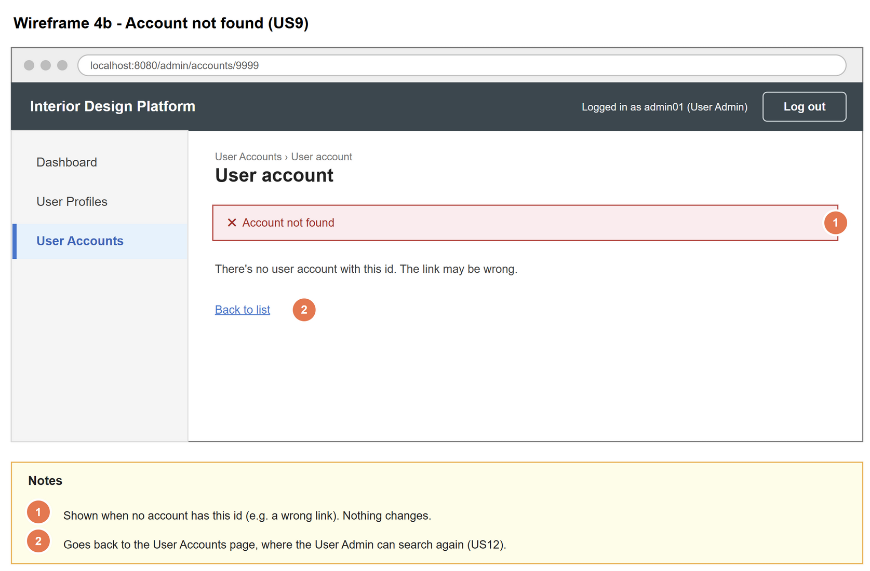
Figure 3: Wireframe 4b - Account not found (US9)

5. B-C-E class diagram
The solid line means the boundary calls the controller. The dashed lines mean the controller uses the entity classes. Only the operations needed for this use case are shown.
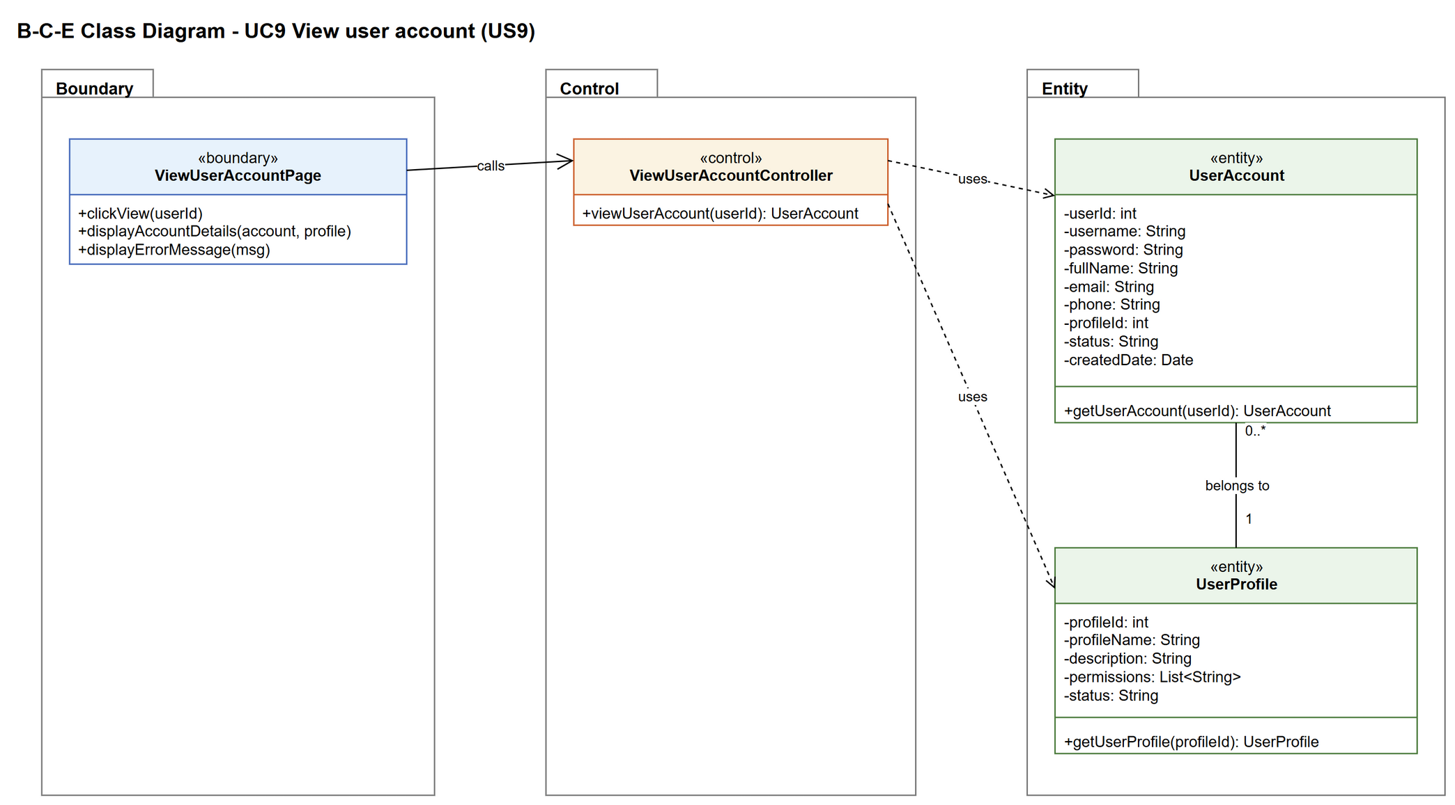
Figure 4: B-C-E class diagram for US9 View user account
Layer | Class | What it does
Boundary | ViewUserAccountPage | The account details page. Sends the chosen userId to the controller and shows the details, or the error message.
Control | ViewUserAccountController | Controller for UC9. Gets the account, then gets its profile so the page can show the group name.
Entity | UserAccount | getUserAccount() returns the account, or null if there is no account with that id.
Entity | UserProfile | getUserProfile() returns the group the account belongs to (1 to 0..* relationship).

6. Sequence diagram
The sequence diagram follows UC9. The note says the userId already comes from the list or the search (UC12). The controller gets the account (step 2). The alt box shows the two ways it can end: the account exists, so its profile is fetched and the details are shown (steps 3 and 4), or it doesn't exist and "Account not found" is shown (alternative flow 2a).
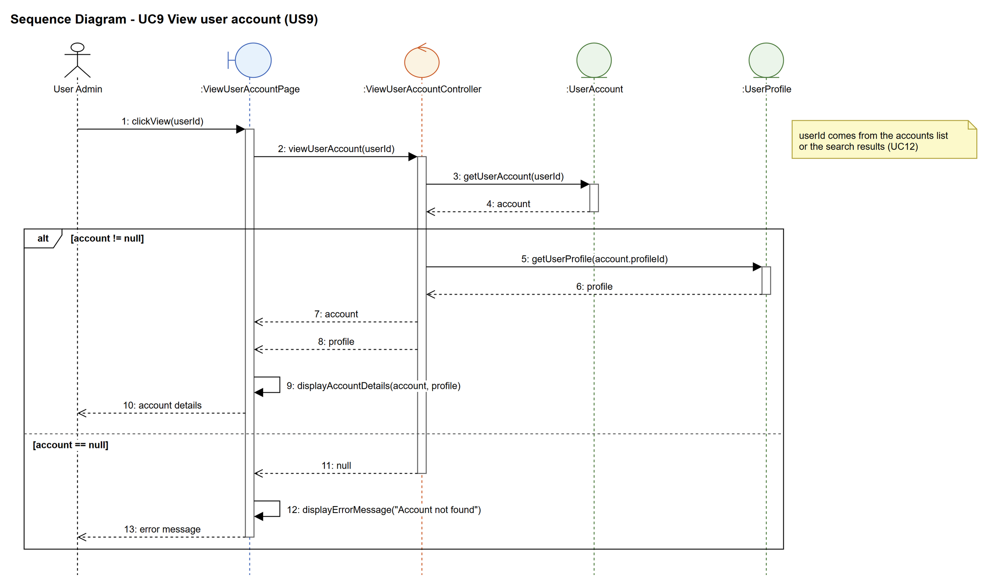
Figure 5: Sequence diagram for UC9 View user account

7. Test cases
Test data used below (same as database/seedData.py): user profiles User Admin (id 1), Interior Designer (id 2), Customer (id 3) and Platform Manager (id 4), all Active. User accounts admin01 / Admin@123 (id 1, User Admin, Active), admin02 / Admin@123 (id 2, User Admin, Suspended) and cust001 / Cust@123 (id 3, Customer, Active).

7a. System test cases (black box)
Equivalence partitioning and boundary value analysis were used to pick the test data. Fill in "Actual result" and "Pass/Fail" after running each test.
Test ID | Scenario | Prerequisites | Test steps | Test data | Expected result | Actual result | Pass / Fail
TC9.1 | View an active account | Logged in as admin01. | 1. Open the User Accounts page  2. Click "View" on cust001 | cust001 | Shows cust001, Chloe Ng, cust001@archss.com, 93456789, Customer, Active and the created date.
TC9.2 | Password is not shown | Logged in as admin01. | 1. View cust001 | cust001 | No password (or hash) appears anywhere on the page.
TC9.3 | View a suspended account | Logged in as admin01. | 1. View admin02 | admin02 | Shows Ben Lim, User Admin, status Suspended.
TC9.4 | Account doesn't exist | Logged in as admin01. | 1. Type the view page URL with userId 9999 | userId 9999 | "Account not found".
TC9.5 | Viewing changes nothing | TC9.1 done. | 1. Check the user_account table | cust001 | cust001's row is exactly the same as before.

7b. Unit test cases (for TDD)
These are written before the code (test-driven development) and run automatically in the CI pipeline. They cover normal inputs, abnormal inputs and boundary values.
Test ID | Class and method | Input / setup | Expected output | Type | Pass / Fail
UT9.1 | ViewUserAccountController.viewUserAccount() | 3 | Returns the account with username "cust001" | Normal
UT9.2 | ViewUserAccountController.viewUserAccount() | 2 | Returns admin02 with status "Suspended" | Normal
UT9.3 | ViewUserAccountController.viewUserAccount() | 9999 | Returns null (no error thrown) | Abnormal
UT9.4 | ViewUserAccountController.viewUserAccount() | 0 | Returns null | Boundary
UT9.5 | UserAccount.getUserAccount() | 1 | Returns admin01 with profileId 1 | Normal
UT9.6 | UserProfile.getUserProfile() | 3 (cust001's profileId) | Returns the profile named "Customer" | Normal

